**HOW TO TRANSFER DEEDS FOR BSP 5828 – NORTH 44 SUNRIDGE LLC – SUNRIDGE ESTATES**

**How do I know it’s a deed for Binding Site Plan (BSP) 5828?**

As we know, not all deeds are the same. However, here are some key things to look for:

On the deed:

1. The parcel number begins with a “9”.
2. It states this transfer is for “IMPROVEMENTS ONLY”.
3. 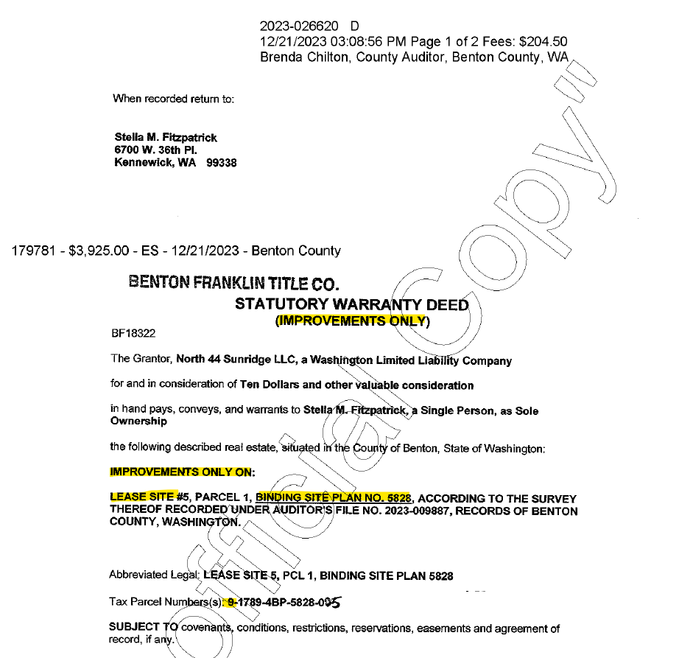The legal description references a “LEASE SITE” and “BINDING SITE PLAN NO. 5828”.

In PACS:

1. There is a group code in the yellow ribbon that says “SALES RESTRICTION”
2. There is a group code in the yellow ribbon that says “XXXXXXXXXXXX”



Once you’ve established the deed is for BSP 5828, has the correct current Grantor, and the legal description matches our system, you’ll complete the steps for transfer found here:   
“This PC > Assessor (G:) > Clerical > Deed Technician > Procedures > Ownership Updates in PACS.doc”.

The following steps are the changes to be made to a “normal” transfer,

1. In the “Comment” section of the transfer screen, you’ll reference that this is a sale of the IMPROVEMENT ONLY parcel of BSP 5828.

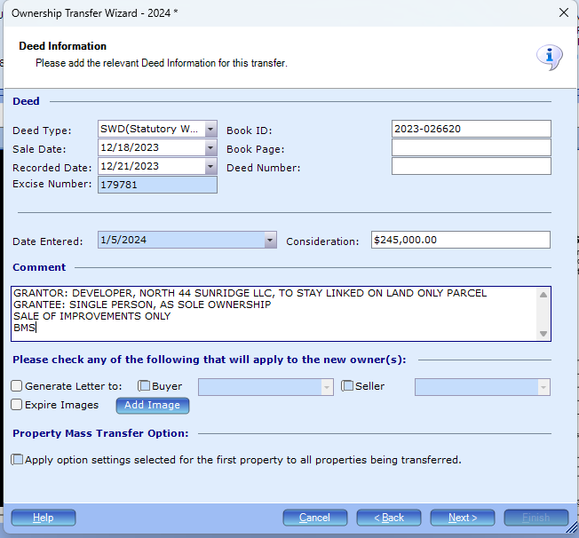

1. In the “Sale Information” tab:
   1. Sale Type: will correlate with the type of deed, in this case, an SWD.
   2. Ratio Code: code as a “27”.
   3. Ratio Code Reason: type “OWNED HOME ON LEASED LAND”.

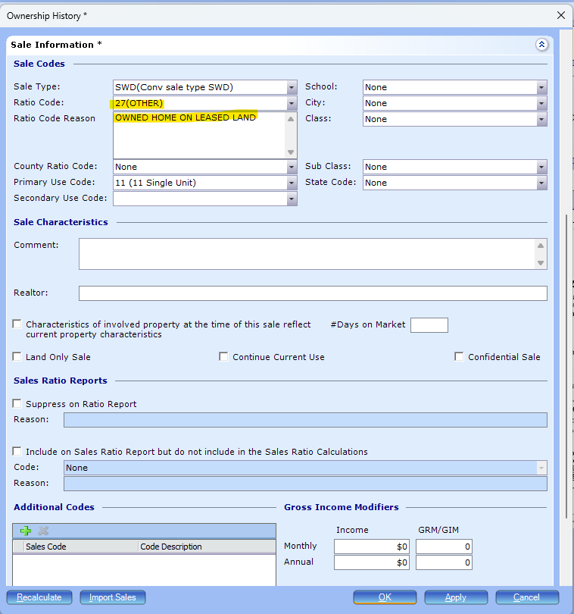

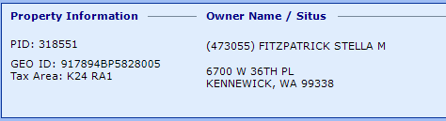After transfer is complete, owner listed on the “IMPROVEMENT ONLY” parcel should be the Grantee on the deed.

1. Now, click in to “Splits, Merges & Property Links” and open the linked “Land Only” parcel.

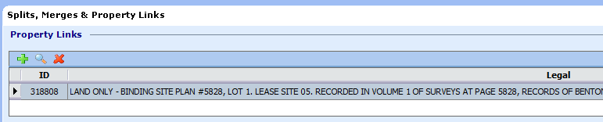

1. In the LAND ONLY parcel, if the developer, NORTH 44 SUNRIDGE LLC, (If the ENTIRE BSP is sold to another developer, this could be different. But ALL the land parcels will have the same “true” owner), is still listed in the main ownership area, we’ll need to move them to a linked owner, where they will stay unless the ENTIRE BSP is sold as mentioned above.

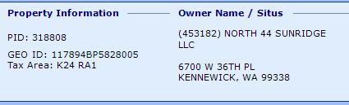

1. Follow steps in “Ownership Updated in PACS.doc” for adding a linked owner.  
   At this point, it should look like this,  
   ** Please do NOT create a new taxpayer ID for NORTH 44 SUNRIDGE LLC, use the existing taxpayer ID (453182).

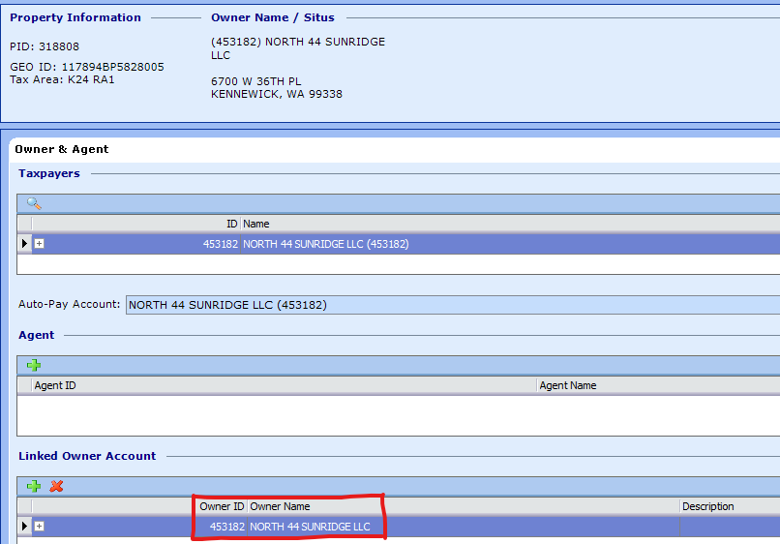

1. If anyone other than the developer, NORTH 44 SUNRIDGE LLC, is listed in the main ownership area, then continue to Step 7.  
   Note: NORTH 44 SUNRIDGE LLC should already be listed as a linked owner.
2. In the LAND ONLY parcel, in the “Owner and Agent” tab, change the Taxpayer to the Grantee on the deed. Grantee should be the same as the new owner on the “IMPROVEMENT ONLY” parcel.   
   Follow steps in “Ownership Updated in PACS.doc” for changing the Taxpayer in this screen.   
   ** Please do NOT create a new taxpayer ID for the Grantee, use the existing taxpayer ID from the “IMPROVEMENT ONLY” parcel. In this case, (473055).

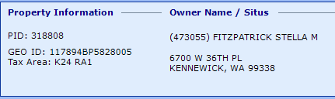

At this point, it should look like this,

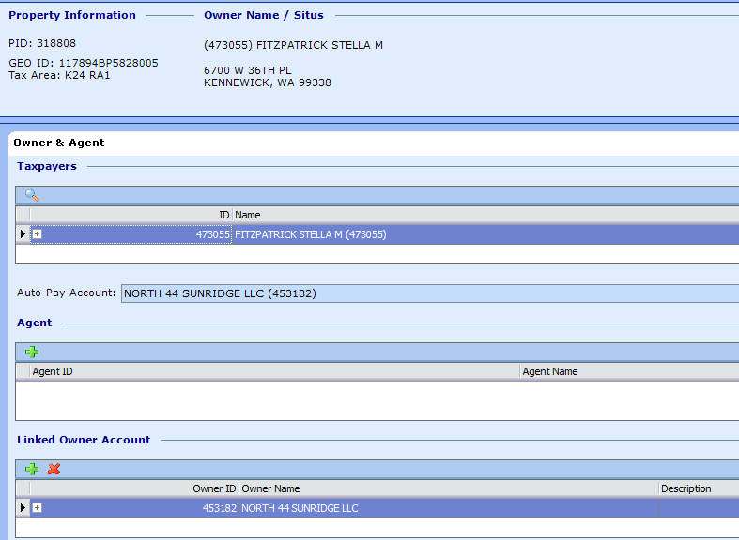

You are done!

The finals should look like this,

IMPROVEMENT ONLY parcel:  
Grantee from deed is listed as primary owner.  
No linked owner (unless multiple people listed a Grantees on the deed).

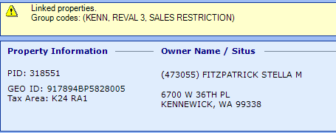

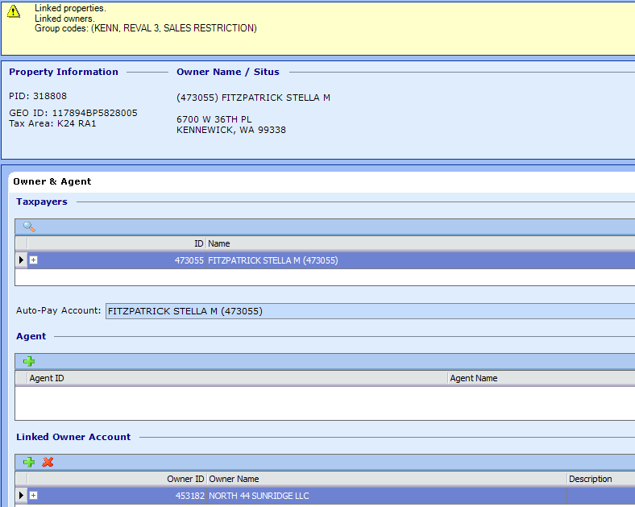LAND ONLY parcel:  
Grantee from deed is listed as primary owner.   
Linked owner is listed as the developer, NORTH 44 SUNRIDGE LLC.

Notes for what just happened and why:

BSP 5828 is where the stick-built homes are owned by individuals, and they lease the land from the developer.   
For example,

PID 318551 & 318808

STELLA M FITZPATRICK owns the IMPROVEMENT ONLY (home) parcel, PID 318551, but she’s leasing the LAND ONLY parcel, PID 318808, from NORTH 44 SUNRIDGE LLC.

We added her to the main ownership screen on the IMPROVEMENT ONLY parcel, PID 318551, because she IS the OWNER of this parcel.

We added her to the main ownership screen on the LAND ONLY parcel, PID 318808, because she is responsible for the tax payments. So, although she’s shown as an “owner” she is not, she’s technically just the TAXPAYER. NORTH 44 SUNRIDGE LLC is the true OWNER of the LAND ONLY parcel, PID 318808.

Note: when someone calls in and asks, “Who is the owner of PID 318808?”, you’ll tell them “The owner of PID 318808 is NORTH 44 SUNRIDGE LLC”.